Sogang Enters into Dual Degree Pact with University of Illinois-Urbana Champaign

Sogang Business School (Dean Gwangheon Hong), an AAPBS member school based in Seoul, South Korea, is set to launch a dual degree program with Department of Accountancy of Gies College of Business (Dean Jeff Brown), University of Illinois at Urbana-Champaign. Sogang Business School of Sogang University is a leading business school in Seoul and AACCB-accredited. Presidents of both universities signed the agreement in latter May, according to Sogang.
According to Sogang, the two parties in the agreement have refined terms and conditions of the agreement for about a year. In detail, Sogang Business School’s MBA students earn credits at Sogang in their first-year curriculum and advance to Illinois’s Accountancy program in their second year. Students who have earned enough credits from both schools will acquire MBA degree from Sogang and MS in Accountancy from Illinois,
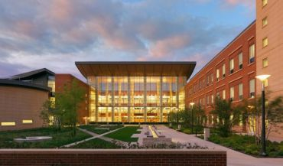
▲ University of Illinois at Urbana Champaign

Sogang added.
Sogang’s flagship MBA program, Sogang International MBA (SIMBA), has been operating an earlier dual degree program with Illinois since 2008 that awards MS in Technology Management, and the two business schools’ agreement on the new dual degree program in Accountancy embodies the two universities’ inspiration and earnestness to further intensify the bilateral academic collaborations, according to Sogang. Sogang noted that nearly 20 of its MBA students have already earned dual degrees on the Technology Management program.
Sogang said that the Illinois’s MS in Accountancy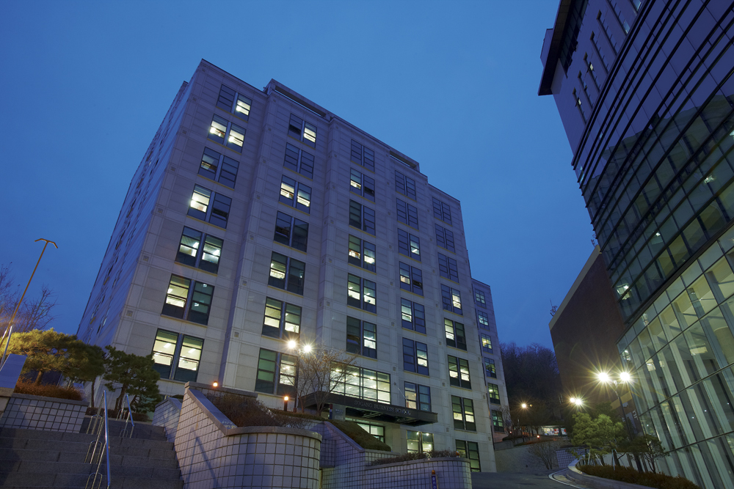
▲ Sogang Business School

program has been rated the best three in the US, according to 2017 U.S. News and World Report. The Accountancy program has been accredited by AACSB on its accountancy accreditation. The dual degree program in Accountancy will become one of the best learning experience for Sogang students on track to earn AICPA as the Illinois Accountancy program has been recognized as the most competitive in the U.S. in the students’ passing ratio of AICPA tests.
Sogang’s on-going dual degree programs with other US and European business schools include those with Marshall School of Business at University of Southern California, Krannert School of Management at Purdue University, and Cass Business School at City, University of London, said Sogang. Sogang said that its on-going dual degree programs with top-rated US and European business schools have been providing students with valuable opportunities learning global market dynamics.
Sogang Business School: www.sbs.ac.kr, Contact for Sogang: gwonkim@sogang.ac.kr

