About AlmaU
Almaty Management University is an entrepreneurial and socially-responsible university. Moreover, University aims to realize new priorities for the near future - to become a “Green University” and strengthen digitalization politics.

University is guided by the experts from business, government and NGO sector. Together they make up the board of trustees, who attend meetings with faculty and staff to discuss important questions and approval of new development policies. Meeting that has been held this semester resulted in the enhancement of importance of becoming become an educational institution in the field of entrepreneurial education, strengthening the development of distance learning courses, providing training for realizing high quality research and publications. AlmaU President Assylbek Kozhakhmetov summed up the meeting with the following words: “Almaty Management University faces new tasks and challenges. Our university is a leader in entrepreneurial education, and in the future should become a leader in the civil society.”

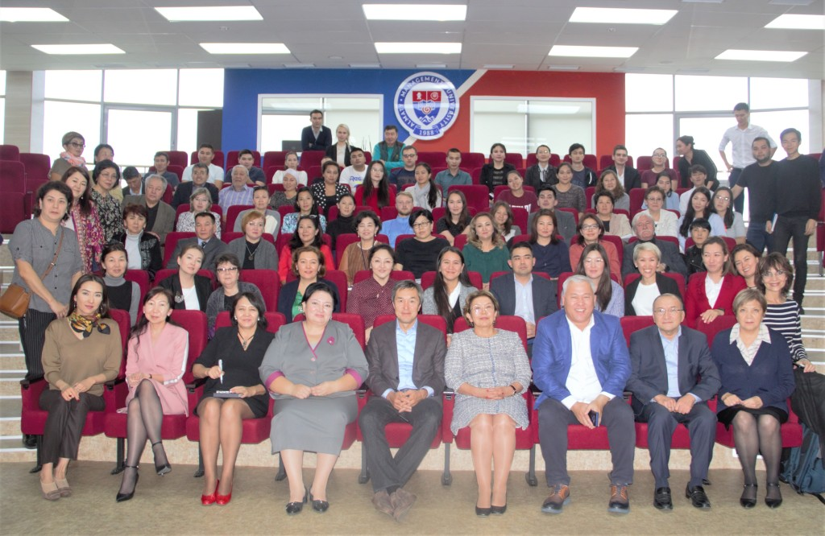
Meeting of Faculty and Staff with the members of AlmaU Board of Trustees

Top positions in Ranking
AlmaU is the only higher educational institution in the Commonwealth of Independent States included in QS World University Rankings. Almaty Management University realizes the principles of the UN’s SDGs, UN Academic Impact and Principles for Responsible Management Education (PRME).
University’s impact within the society and development of social responsibility has been evaluated by Times Higher Education Ranking (THE) and AlmaU was ranked in Top 301+ Universities in the THE Impact. Every year University confirms its global impact and hold the position of a top 3 Business Schools in Central Asian region according to Eduniversal (France) and top 5 Business Schools in the CIS Region according to “ExpertRA” (Russia).
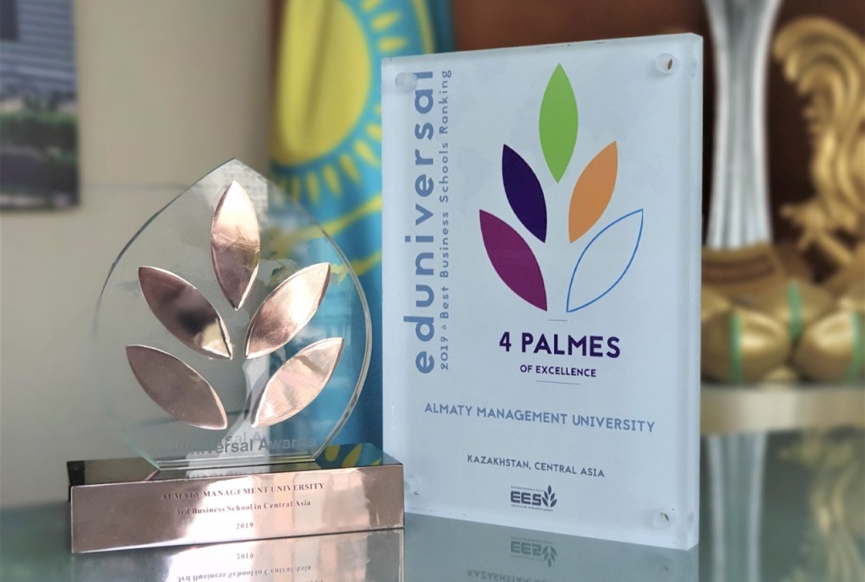
AlmaU received the award of Eduniversal global ranking agency - 4 Palmes of Excellence and entered the Top 3 best business schools in the Central Asian zone
International Development and cooperation
International Development is one of the strategic directions of the University’s internationalization. University holds strong connections with more than 40 countries’ representatives, including 155 partner institutions and more than 20 associations. Main directions of cooperation are academic mobility of faculty and students, double degree programs, joint international projects, experience exchange, research and development. This semester was enhanced by the visits of the Ambassador of the Netherlands to Kazakhstan, Ambassador of Malaysia to Kazakhstan, US Consul General, Consul General of Poland, which allowed the University to broaden the cooperation opportunities within the business sector as well as reach out to the educational sphere of those countries.
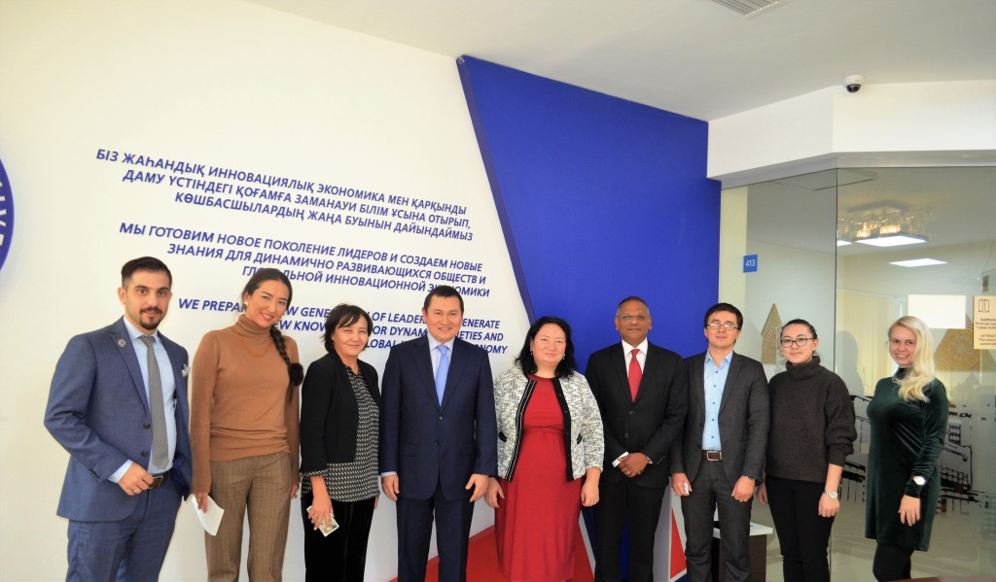
Visit of His Excellency Ambassador of Malaysia Mr. Dato’ Syed Bakri along with Mr. Suresh Kumar, the Counsellor of the Trade Section (MATRADE)
AlmaU is very proud to have many international students and International Office constantly organizes multicultural events, lectures and meetings for them so that they will feel Kazakhstan’s hospitality, get adjusted more easily to the local culture and have fun. Consul General of Uzbekistan provided support to the Uzbek students by meeting with them at the University. The Afghani students were greeted warmly by the Deputy Consul General of the Islamic Republic of Afghanistan during their adaptation this autumn.
Many more strategic partners of AlmaU visited the University to widen collaboration opportunities, including EFMD Global, Saint Cloud State University (USA), Ural Federal University (Russia), Baltic International Academy (Latvia), Taylor’s University (Malaysia), Hof University of Applied Science (Germany) and other.
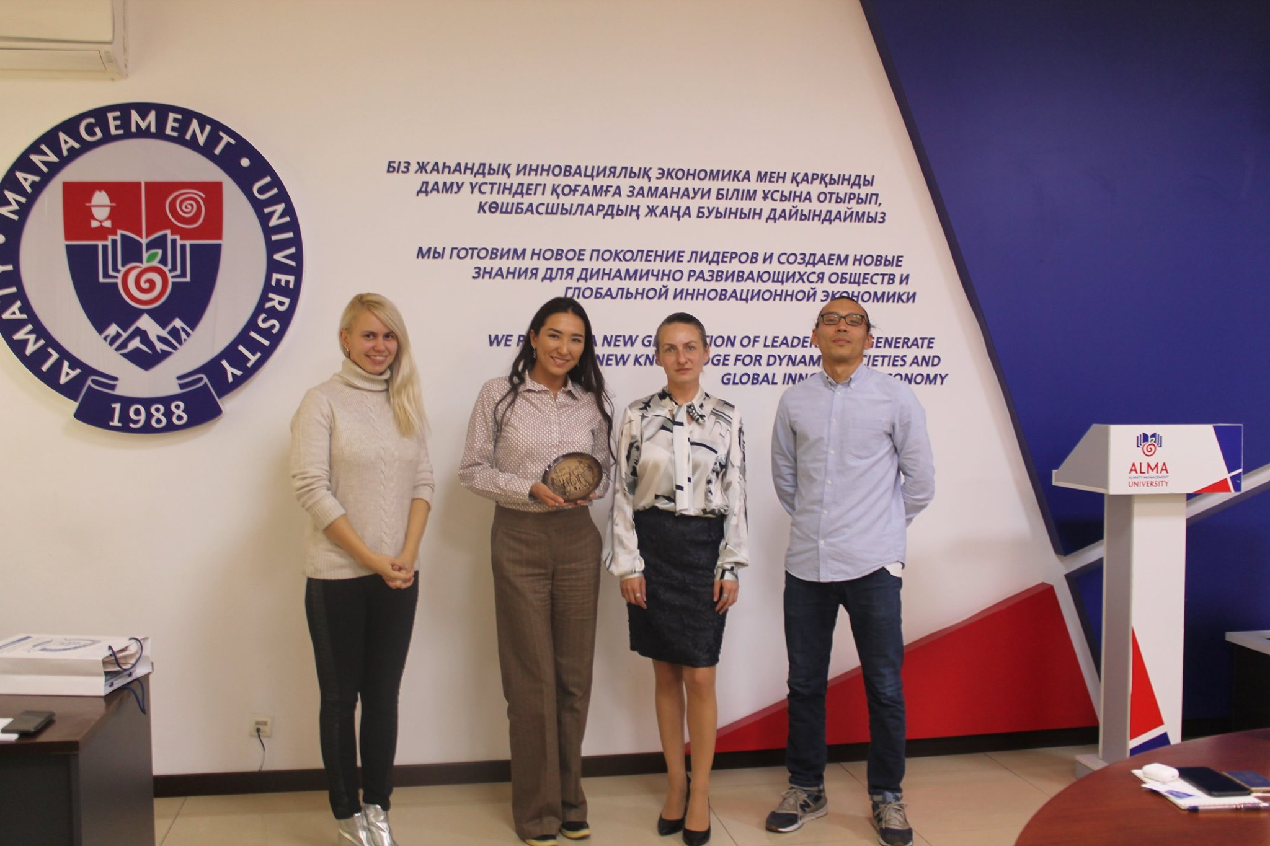
Senior Advisor to the Rector, Vice Dean of the School of Public Policy and Law, Head of International Cooperation greeting the University’s strategic partner- Baltic International Academy
On December 9th AlmaU celebrated the most exciting and spectacular event- International Day.
Representatives of 13 countries showed theatrical performances, national cuisine, beautiful costumes and the parade of the flags under the University hymn. More than 250 attendees including AlmaU local and international students, faculty and staff members, honorary guests from the government sector and NGO’s came enjoy this bright event. The day is known as the most loved and epic celebrations of the year. International Day of Almaty Management University unites students and faculty from all over the globe and celebrates friendship, peace and unity.

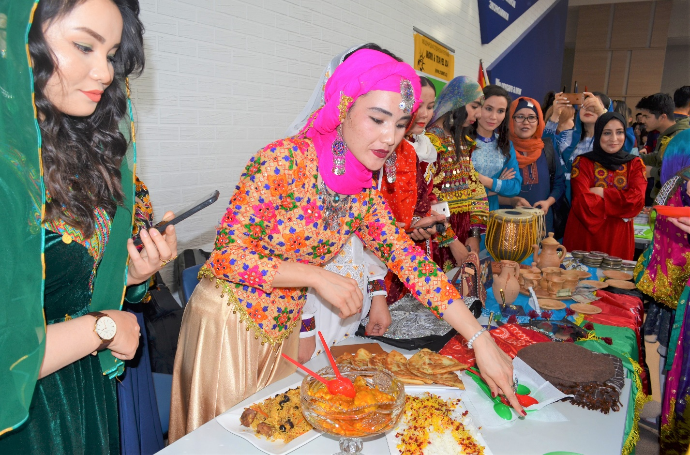
Afghani students treating guests their national food during the International Day this December 2019

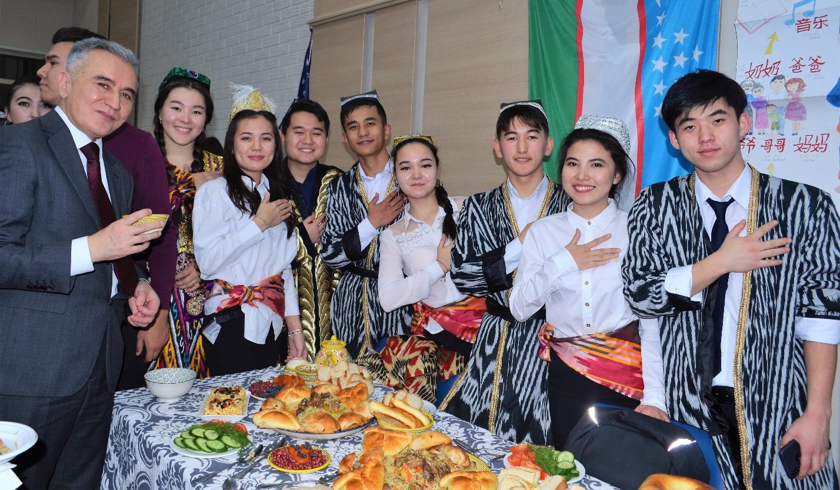
Students from Uzbekistan showing their hospitality to the honorary guest of the event- Consul General of the Republic of Uzbekistan in Almaty

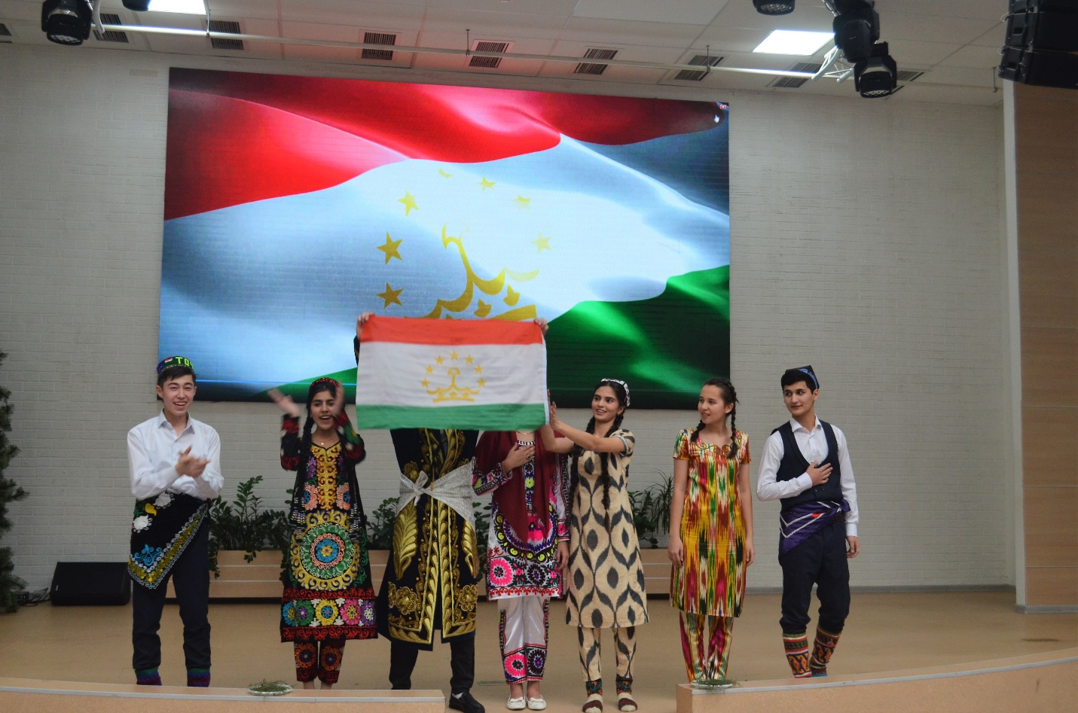
Team from Tajikistan won in the “Best team performance” nomination with their beautiful song and traditional dance.

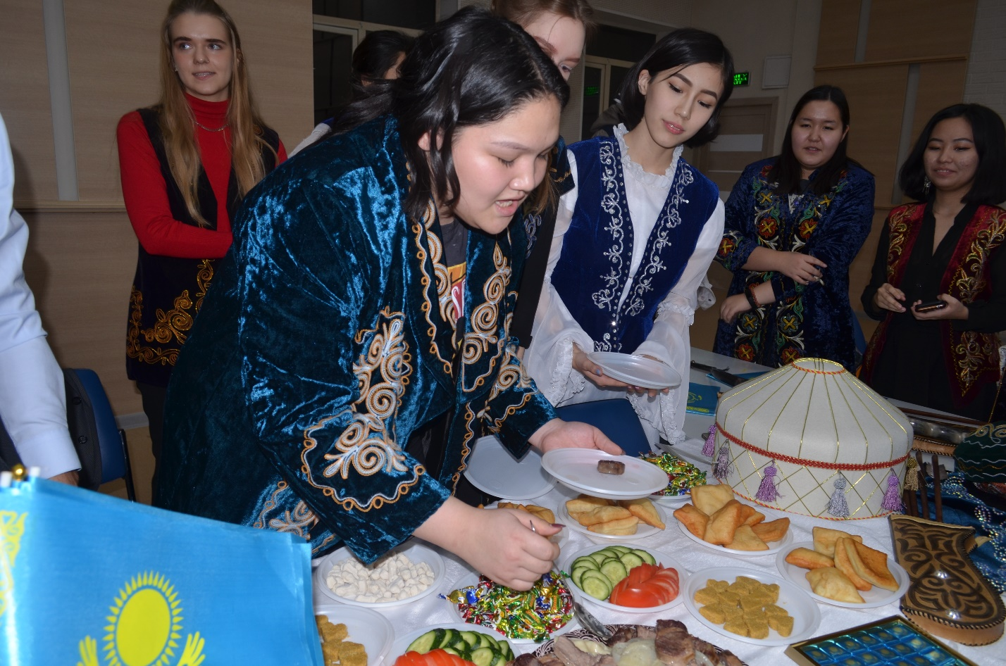
Kazakhstani team demonstrated strong patriotism by cooking the national Kazakh dish “Besbarmak”

Social projects
Social activity was especially actual for this year. Range of important projects were getting into life. Among them “School of the realized future” held at the end of autumn. More than 140 participants from different regions of Kazakhstan took part in the project. School united open-minded specialists from the sphere of education and became the center of progressive discussions about the future of education and the country perspectives.

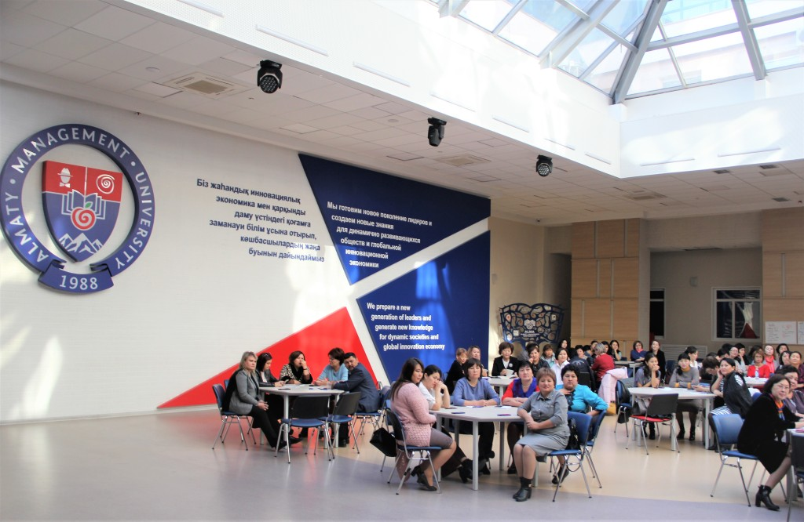
Teachers and invited guests during the “School of the realized future” held at the Atrium Grand Hall of Almaty Management University
Another outstanding project “Support of rural schools by Kazakhstani Universities” which was initiated by the President of AlmaU – Dr. Kozhakhmetov more than 10 years ago. And, it is still successfully running. Twice a year the University gathers teachers from rural school across the country in order to raise their managerial skills and knowledge.
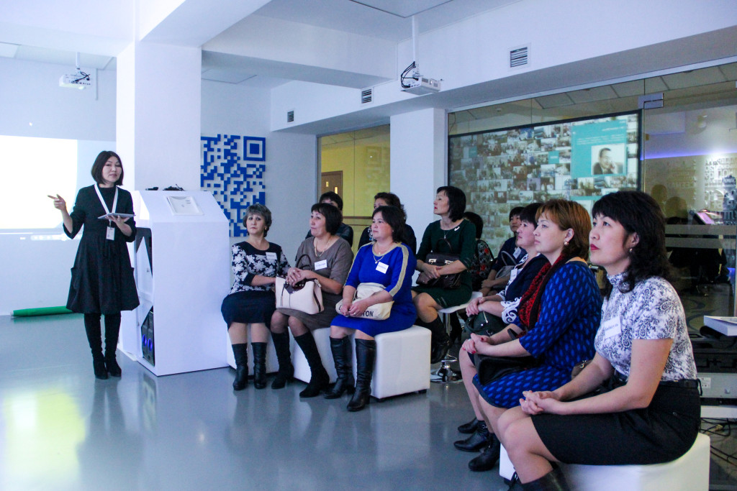
Teachers from the rural areas of Kazakhstan have been given a scholarship from AlmaU to come to Almaty and receive high quality training in management.
This study year Almaty Management University engaged in the UNDP Project funded by the European Union which aims to educate 30 women from Afghanistan to raise their rights and provide work and business opportunities. This autumn Almaty Management University held the official gala event where the Ambassador of the EU, Vice Minister of International Affairs of Kazakhstan, Representative of the UN in Kazakhstan and the Ambassador of the Islamic Republic of Afghanistan and University team greeted Afghani women and set the start to the project. Students started to study on the AlmaU Foundation program where they will get strong basic preparation of the Russian and English languages as well as Mathematics that will allow them to enter into Bachelor level studies of any Kazakhstani or Uzbekistani Universities upon completion.
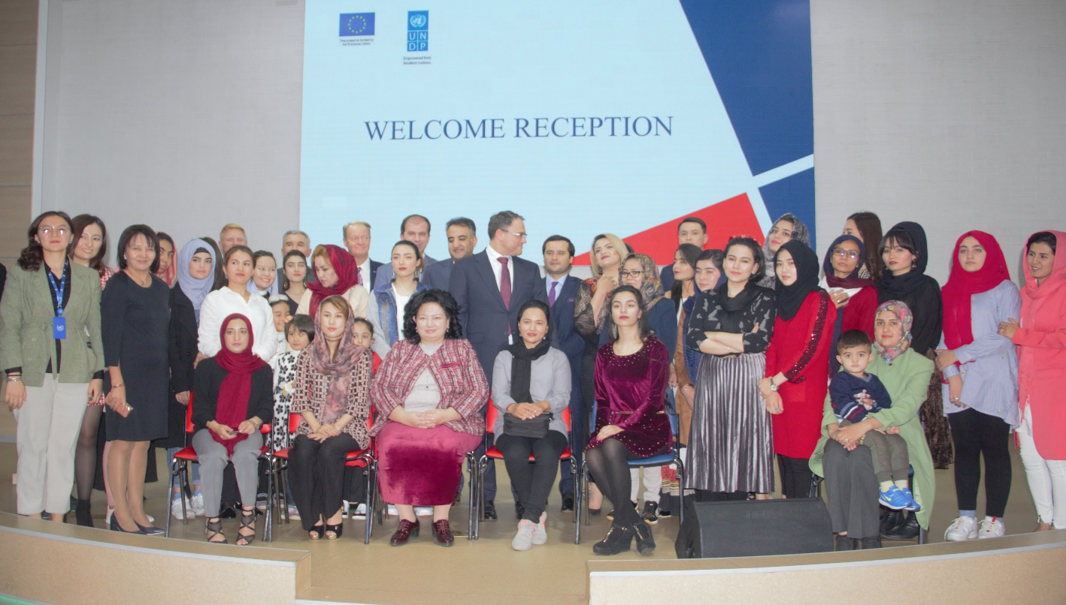
Welcome reception for the Afghani Women, UNDP and honorary guests.

Regional development
Regional development remains to be a strategic aim for the University. AlmaU has several representative offices across the country which allows to significantly widen the opportunities and accessibility of the business programs listeners and social projects participants around Kazakhstan.
Graduate School of Business
2019 year- has been a year of new ambitions for the Graduate School of Business. Nowadays the competition no longer occurs between the companies, products or services, but between the managerial models of organizations. Graduate School of Business plans to continue educating managers in applied knowledge and skills in all educational spheres by enhancing the consulting through new research labs, such as “Coach Laboratory”, “Laboratory of Corporate entrepreneurship”, and other. An entrepreneurial ecosystem is on a verge of being realized within the school, as well as impact the Kazakhstani businesses and society. Kazakhstani business’s and society’s main aim now is to transform the corporate managerial models to meet the challenges of the modern time.
Based on the high-quality programs of the Graduate School of Business, Almaty Management University was included into Global MBA Rankings 2020 rating. MBA programs of Almaty Management University are in the TOP-200 in QS World University Rankings: Global MBA Rankings 2020 and TOP-20 in Asia. MBA program in Financial Engineering was successfully accredited by Global Association of Risk Professionals.
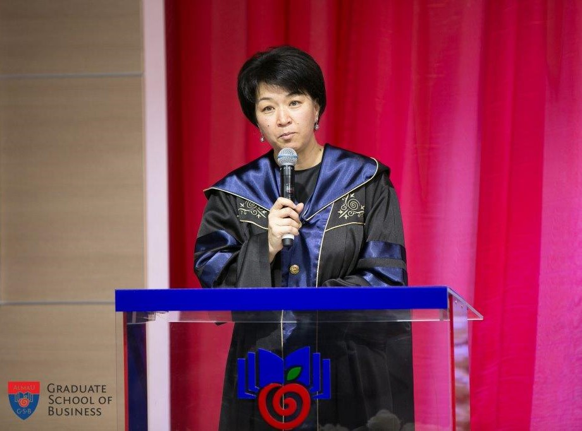
Dean of AlmaU Graduate School of Business – Dr. Gulnar Kurenkeyeva is elected as a member of AMBA International Accreditation Advisory Council

Entrepreneurship
Entrepreneurship Summer School “Made in Kazakhstan” was held at AlmaU for Students from Hong Kong in mid-summer. Ten students of Lingnan University came to Kazakhstan to attend trainings in entrepreneurship in Kazakhstan, exercising attracting investment, art of marketing, creating a business in Kazakhstan and many others. Moreover, in addition to theoretical knowledge, the participants had the opportunity to study real cases basing on activity of Kazakhstani companies. Foreign students visited these companies.
Another important aspect was interexchange between guests from Massachusetts Institute of Technology – AlmaU students & LU students. MIT students came to Almaty following MISTI Kazakhstan project that opened them opportunity to have internship at different organizations of Almaty city. We hope that such friendly inter-relation between projects, countries and foreign students will result with outstanding projects in the sphere of business, education and social activity.
Creating the new generation of faculty members and specialists in the sphere of education AlmaU organized summer school “Education of Future: design, content and forms” in Georgia. These great socially oriented event gathered bright speakers and trainers, like-minders and friends.
Annually School of Entrepreneurship and Innovation organizes Start-up night where students develop their project management skills, meet experts from the field and present their ideas on Sustainable Development Goals.
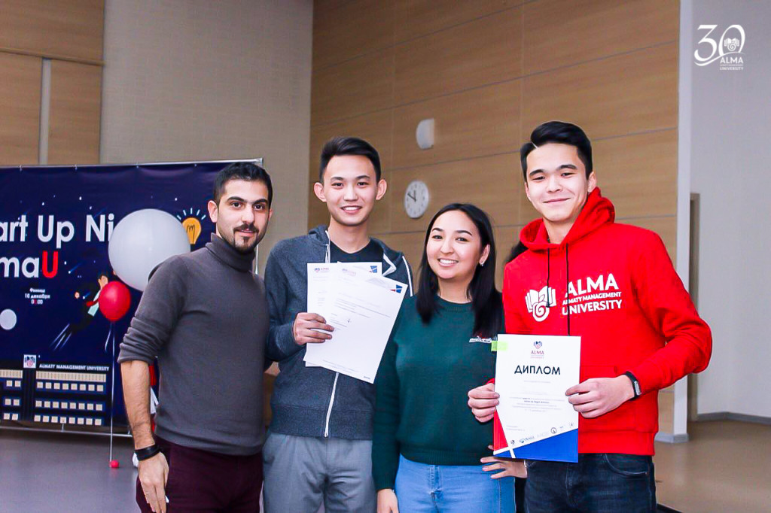
Students from the Minor – Entrepreneurship along with the Dean of School of Entrepreneurship and Innovation present their award-winning project during the Start Up Night at the University.

