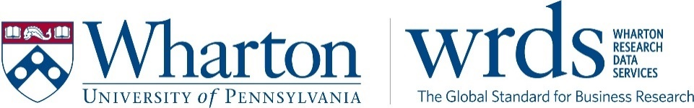

The Global Gold Standard for Research, Data Access, and Impact for over 25 years

The mission of Wharton Research Data Services (WRDS) is to provide students and scholars with extraordinary access to data, tools, analysis, and support to advance business research, education, and impact. A division of the Wharton School of the University of Pennsylvania, WRDS brings the equalizing power of global data to over 75,000 users at 500+ institutions in more than 35 countries. WRDS researchers conduct impactful research throughout the Asia Pacific region at universities in China, Hong Kong, Japan, Malaysia, Philippines, Singapore, South Korea, and Thailand.

Listening to researchers, creating new products and services to meet their needs
WRDS has grown by listening to our expanding subscriber base through the addition of new data, development of analytics tools, classroom resources for teaching, and enhanced doctoral-level support. As COVID has accelerated the way technology is deployed in the delivery of our academic programs, WRDS technology infrastructure was designed around making data accessible to and supportive of the unique needs of our core users. During this period, WRDS enhanced our Learning Pathways — providing curated, guided resources for Researchers, Instructors, and Information Professionals.

Helping emerging business program gain visibility
As the world becomes more connected and the impact of policy reaches across borders, equity and access become more essential to research. WRDS is proud to play a leading role in reshaping how research, data access and researcher recognition can better reflect and support a truly global and networked user base. To meet the global call for greater emphasis on the impact produced by academic research, WRDS created a series of Best Paper and Innovation Awards to highlight schools and authors conducting impact-focused work. These awards recognize researchers and extend the reach of their work through peer recognition and press coverage, and further develops a knowledge base of results-driven insights.
Looking ahead
As the global gold standard in business intelligence, we recognize what sets us apart, and what we build on for the future: the wisdom to listen to clients around the world, understand emerging and established regions, push the boundaries, and innovate at every level to meet new needs and support greater research.
Learn more
Contact us to find out how WRDS can support your institution’s research and teaching needs.
Erica Zhang, Associate Director of Client Development | xiazhan@wharton.upenn.edu |
wrds@wharton.upenn.edu | http://whartonwrds.com

