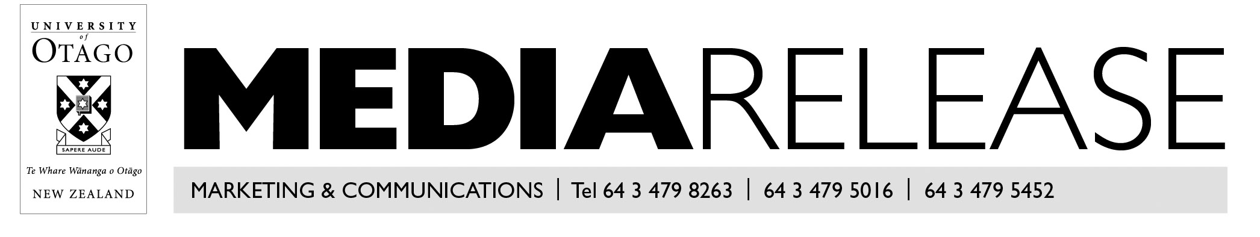

March 2019

China launch for world-leading Otago MBA programme

The University of Otago online Master of Business Administration (MBA) programme is set to launch in China next year.
The announcement comes on the same day CEO Magazine confirmed the Otago programme has retained its third place ranking in its annual Global MBA Rankings.
University of Otago Executive Programmes director Ian Lafferty says both announcements are evidence of the consistent quality of the programme.
The online MBA will launch in China in partnership with Beacon Education, he says.
“Beacon Education has developed a comprehensive online platform which delivers in-country student outreach, marketing and social media, student recruitment, programme delivery and local support. Otago will provide the content and the teaching for the programme.”
The first two cohorts of a total of 50 students will start in 2020.
“China offers a great growth opportunity for Otago. There are vast numbers of business graduates seeking a quality MBA from an international university,” Lafferty says.
“This will be significant for Otago. The university currently has around 500 students from China, so this would represent an approximate growth of 10 per cent per year on that number – from just one programme.”
This is the fourth year the Otago online programme has been running and the third consecutive year it has been ranked in the top four online MBA programmes globally.
CEO Magazine has been ranking business schools since 2012. This year 71 online MBAs were ranked from business schools around the world.
“I think it is about real engagement with students. The lecturers, the Zoom team and the programme management team build strong relationships with the students throughout their MBA, from start to finish. This is as easy to do with online students as it is with on campus students,” Lafferty says.
While ranking third - behind the EU Business School and SBS Swiss Business School – is something to celebrate, Mr Lafferty says there is no room for complacency.
“We came third, which means we still have room for improvement. We need to maintain and grow the quality of our teaching team as this is the most important criterion in the CEO Magazine ranking.”
Otago Business School (OBS) Pro-Vice Chancellor Professor Robin Gauld says the ranking is a “stunning achievement”.
“Otago’s online MBA was ranked third last year, and fourth the year before. Retaining third in a very competitive global market is something for our MBA programme and OBS to be very proud of, particularly as the number of ranked programmes is considerably more this year than last.
“This also suggests that the CEO Magazine rankings are being noticed by MBA providers and prospective students,” Professor Gauld says.
The rating should not be taken lightly, he says.
“The CEO Magazine rankings, like others such as QS (an annual publication of university rankings), are important as they look at various elements of the MBA programmes that are ranked. The higher-ranked programmes, such as Otago’s, are obviously performing better across the range of key areas of interest, meaning that the quality of the programme is high, along with its reputation.”

For more information, contact:

Ian Lafferty
Director, Executive Programmes
ian.lafferty@otago.ac.nz
(03) 479 8165

Professor Robin Gauld
Pro-Vice Chancellor, Division of Commerce
Otago Business School
robin.gauld@otago.ac.nz
(03) 479 8632

Lea Jones
Media adviser
Department of External Engagement
lea.jones@otago.ac.nz
(03) 479 4969
021 279 4969

