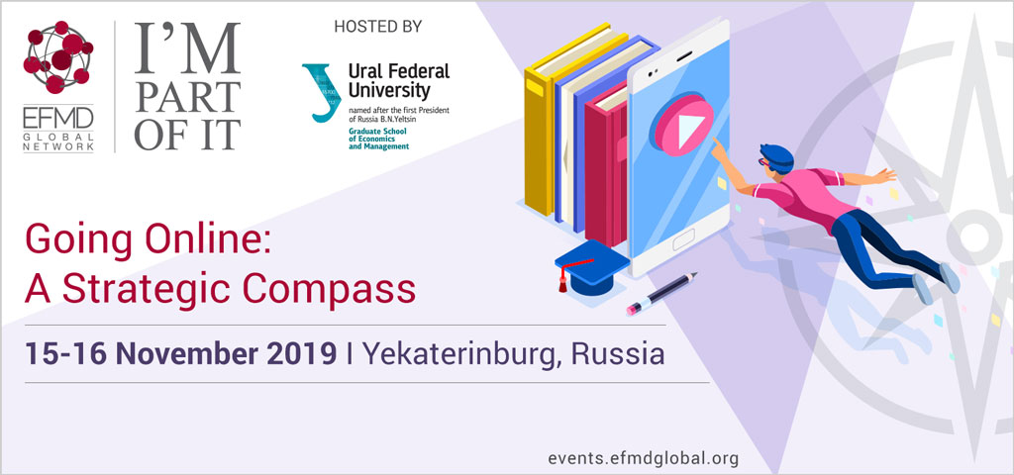

Going Online: A Strategic Compass represents an intensive 1.5-day course designed to provide participants with comprehensive strategic overview of the value chain in designing online teaching & learning experience.

The programme is divided into five parts; the first four parts consist of delivered material which is concluded with an informal wrap-up discussion where participants are invited to reflect on the material in their own context and interact with others. The initial three sessions define the ‘what’ and the ‘how’ in delivering online education, the fourth session draws together this subject matter in how an institute may craft effective delivery in reality. The final part of the course features a group assignment that encourages individuals to apply what they learned while creating a case for online delivery specific to their institution.

Learning outcomes
Different approaches will be combined to enable participants to build a comprehensive roadmap towards online & blended learning encompassing strategic, financial, pedagogical and operational perspectives.

Emphasis will be equally placed on critical understanding of both the external environment and the internal conditions which formulate the layout of this roadmap. Ultimately, the participants will gain a sound methodology to start crafting an online strategy in line with their institutional objectives.

The programme will take place at Graduate School of Economics and Management, Ural Federal University in Yekaterinburg, Russia 15-16 November 2019. It is designed for Business school executives overseeing a business school’s transition to online teaching or decision makers in charge of the digital innovation at business schools, corporate universities and L&D units.

For more information on the programme, please visit our website or contact andrea.maresova@efmdglobal.org

