Subject: Call for Session Proposals – GBSN Beyond 2021: Virtual Conference Reimagined
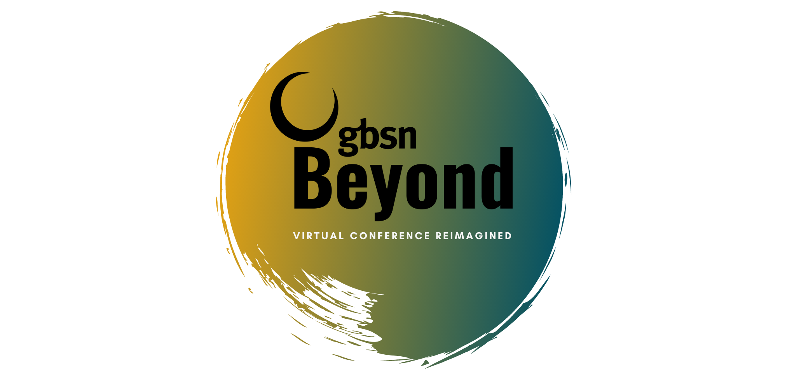
Connect with a vibrant hub of exchange, learning, collaboration and discussion by preparing a proposal for GBSN Beyond 2021. Beyond will be hosted November 8-10, 2021 with 3 parallel track experiences leading up to the conference in October. Our innovative approach to what a virtual conference can be hopes to create an engaging community that will collectively explore multi-sector collaboration in development. We invite you to join the conversation by submitting a session proposal.
Conference Topic – Business schools are ideally placed to be the nexus between government, business and civil society in shaping a collective response t our most critical challenges. At GBSN Beyond, we hope to

collectively explore multi-sector collaboration in developing talent needed for society.
Themes/Prompts - GBSN seeks a diversity of perspectives for sessions across 4 overarching themes – Humanitarian Logistics, Climate Change, Healthcare and Human Rights. Prompts for the sub-themes of cross-disciplinary collaboration, sustainable and ethical leadership, technology and big data and the tools of innovation and entrepreneurship are available to help guide session proposals.
Session Formats – GBSN hopes to provide a variety of live and on-demand content during the conference. Plenary session formats available include keynote addresses, stakeholder dialogues, and firestarters. On-demand session formats include bite-sized innovations, skill-up, and Pechkucha/Ignite.
Key Dates – The Call for Session Proposals is now open until July 16, 2021. Selected speakers will be notified by August 2, 2021, and are require to confirm their session by August 13, 2021. The conference will be held November 8-10, 2021.

Details - Descriptions of the session formats, submission details, general information, and the submission link are available on the GBSN website at https://gbsn.org/conference/beyond2021/call4session-proposals/. Question can be submitted to beyond@gbsn.org.

